Blount County Schools'
2022
Partners for Kids
Campaign

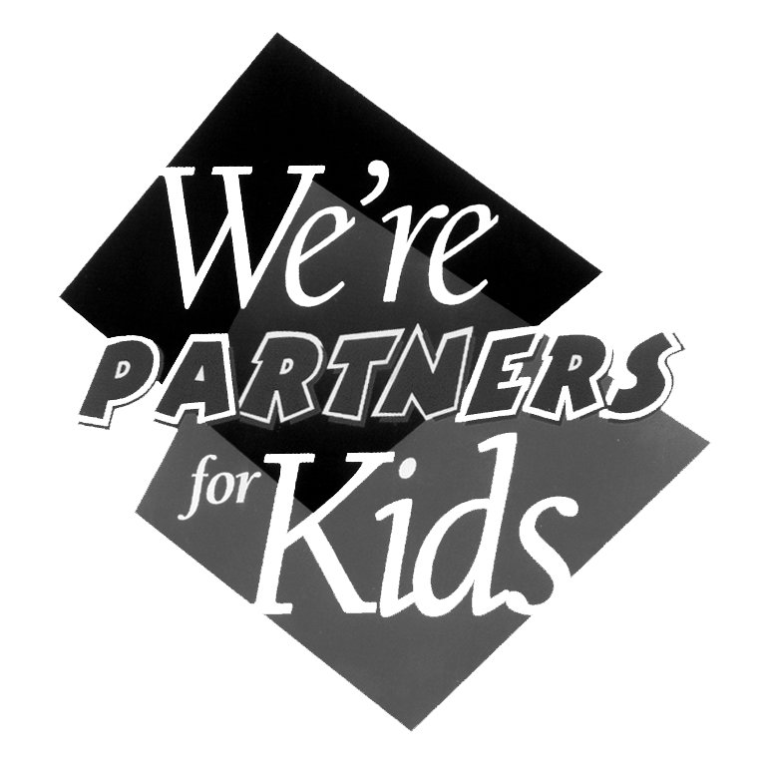

COORDINATOR'S ORIENTATION
MEETING

2022 Partners for Kids
Campaign

Presenting Sponsor
Good Landlords of Blount County

Media Sponsors
DUKE FM
WIMZ
THE DAILY TIMES

Major Sponsors
KenJo Markets - Papa John's Pizza
CBBC Bank

Supporting Sponsors
Chick-fil-A – Sir Goony's - McDonald's - Blount Discount Pharmacy – Parks & Recreation - The Great Smoky Mountains Heritage Center - Burger King – Aubrey’s Restaurants – Titanic Museum Attraction

Prizes & Incentives
Individual Awards

LEVEL ONE
Sell one book:
Participation Level:
Receive Participating Student's Fun Pack
Free Frozen Coke from Burger King
Free Admission to The Great Smoky Mountains Heritage Center

LEVEL TWO
Sell three books:
Performance Level:
One Student's Fun Pack from Level One
Free Golf Certificate from Sir Goony Golf
Free Fries and Soft Drink from McDonald's K - 8
Free Fries and Drink from Burger King

LEVEL THREE
Sell five books:
Achiever's Level:
Receive all prizes from Level One & Two
Free McDonald’s hamburger, cheeseburger or 6 pc. McNuggets, small order of French Fries and Small Soft Drink: Enclosed K - 8
Free Pizza Certificate from Papa John's Pizza

LEVEL FOUR
Sell ten books:
Super Achiever's Level:
All prizes listed above
FREE Chicken Sandwich or Nuggets from Chick-fil-A
Four Color Partners for Kids T-shirt

Top Seller's Prize
The Top Selling Student in each participating school receives a season pool pass from Parks and Rec.
The Over All Top-Selling Student in the Campaign wins $200 Cash from Good Landlords, Inc.
The Over All Top Selling Runner-up Student wins $100 Cash from Good Landlords, Inc.

Prizes & Incentives

Student Team Prizes

Top Selling Classrooms
The Top Selling Class Room, based on TOTAL sells in each participating school, earns a classroom pizza party from Papa John's Pizza & Free Admission for the entire class at Titanic Museum

Top Selling School
The Top Selling School of the event, based on average sells per enrolled student, receives a School-Wide Super Pizza Party from Papa John's Pizza

For a Job Well Done
Teacher Awards
The Five Top Selling Classroom Teachers of the event, based on TOTAL sells, receives a $50 Gift Certificate from Aubrey’s Restaurant

Principal's Pick
The Principal of the Top Selling School, based on TOTAL sells, wins twenty-five Partners for Kids $1.00 Off per Gallon gift cards from KenJo Markets (up to a $500 Value)

Enhanced Prize Options

Prize Ideas by Grade Level

Elementary Schools
No cost ideas:
First in line for day, week, month, etc.
Cut the principal's tie or scarf
Pie in the principal's face
Principal to kiss a pig
Extra recess time
Watch a movie on school time
Principal or teacher for a day
Principal carry food tray
Name on the wall for each book sold

Ideas that cost:
Limo to lunch
Gift Certificate to popular store in the area
Special pizza or ice cream parties not included in Primary Prize Package
Partners for Kids T-shirt or one with school logo
Trolls, plush animals, and dinosaurs
Sporting event passes
Nintendo’s and other electronic games
Books and other educational materials
Middle Schools
No cost ideas:
Principal on the roof for a day
Cut the principal's tie or scarf
Pie in the principal's face
Free yearbook
Watch a movie on school time
Coach or principal shaves his head if goal is reached
Season tickets to school athletic events
Principal or teacher for a day
Sitting next to coach on the bench during the games
Name on the wall for each book sold

Ideas that cost:
Limo to lunch
Mall Gift Certificate
Special pizza or ice cream parties not included in Primary Prize Package
Partners for Kids T-shirt or school logo items
Fashion show / this could be free if the store will donate the items
Sporting event passes
All electronic games
Movie tickets
Rollerblades
CD Players
Enhanced Prize Options
Prize Ideas by Grade Level

High Schools
No cost ideas:
Kiss a pig; winner selects which member of faculty will do the honors
Free tickets to the next dance
Reserved parking
Free yearbook
Free prom tickets
Coach or captains shaves his head if goal is reached
Season tickets to school athletic events
Principal or teacher for a day
Sitting next to coach on the bench during the games
Name on the wall for each book sold

Ideas that cost:
Limo to lunch
Mall Gift Certificate
Special pizza or ice cream parties not included in Primary Prize Package
Partners for Kids T-shirt or school logo items
Fashion show / this could be free if the store will donate the items
Sporting event passes
All electronic games
Movie tickets
Rollerblades
CD Players

SAMPLE PARENT LETTER
Letter One

Send home with student on school stationery

Date

Dear Parent:

We are very excited about our involvement in the 2022 Partners for Kids / Patron Check Campaign. Our school has the opportunity to raise much needed funds and to compete with other schools in the community. Our goal is to raise enough funds to .........., and with everyone's support and cooperation, we can achieve our goal.

This year's Patron Checkbook is better than ever! It's stuffed with serious savings from restaurants, entertainment attractions, and top retailers. The Patron Checkbooks are available for only a $10 donation to our school. Even after all expenses, our school retains 75% of everything we raise.

Some of the free offers you'll see in the 2022 Patron Checkbooks are:

This is free stuff:
KenJo Markets - Free Ultimate Car Wash
UT Lady Vols - Free admission for the whole family to Women's Soccer, Baseball, or Volleyball Games
Maryville College - Free admission for the whole family to any athletic event
Sir Goony Golf - One Free round of golf for the entire family
plus, free tire rotations, and a whole lot more; over $100 worth of FREE STUFF, and over 70 " Buy One - Get One Free" offers from restaurants, attractions, and entertainment locations.

As you can see, by using the Patron Checkbook your $10 donation will be repaid many times over. So, please help your child secure donations for as many Patron Checkbooks as possible. Many prizes are available for the children, classrooms, and the entire school. Let's make 2022 our best year ever, and become Partners for Kids!

The campaign starts today and runs through September 6th.

Sincerely,

Principal

SAMPLE PARENT LETTER
Letter Two

IMPORTANT
PATRON CHECK COUPON BOOK SALE

For only a $10 to our School, you'll receive:

Discounts from Family Fun Places like:
McDonald's
Papa John’s Pizza
Taco Bell
Sonic Drive-In, and many others
Sir Goonie's Golf, Burger King
Over $100 worth of totally FREE STUFF!
Over 70 Buy One - Get One Free Dining and Entertainment locations. Plus Much, Much More

OUR SCHOOL'S GOAL: $___________
The funds will be used for ___________________________________
Your child should have come home today with one Patron Checkbook and order form to begin taking orders. If you do not wish for your child to participate in this area wide project, please return the book. However, he or she has an opportunity to help our school, learn to work as a team, and to earn many exciting prizes (see included prize sheet).

Thank you in advance for your support!

If you want your child to receive more than one Patron Checkbook, please fill out the form below.

I wish to receive _______ extra Patron Checkbooks for my child, _________________________
I understand that the money for the books is due no later than ____________________ .

Parent's Signature __________________________________________

SAMPLE PARENT LETTER

Letter Three

Send home with student on school stationery

Date:

Dear Parent,

Blount County School's annual Partners for Kids Patron Checkbook Campaign begin today. Most area schools are participating in the effort, and once again, we are excited about being involved in the project.

Our tax allocations do not cover everything we need to maintain quality programs for our students. We want to continue providing the best education possible, and we need your help and support.

Last year we raised $ ____ through the Partners for Kids Campaign. With those funds we were able to _________ .

This year’s Patron Checkbook is bigger and better than ever. It includes over two hundred true discounts from area merchants; as well as chances to win exciting prizes. There are several free outings for the whole family, and over seventy "buy one - get one free" offers from restaurants and entertainment locations throughout the area.

Starting today, the Partners for Kids Campaign runs through ............; we are attempting to raise enough money to ...............................

The Partners for Kids project is a total community effort with many of the area's businesses involved. The Patron Checkbooks are available for a $10 donation to our school. Even after all expenses of printing, distribution, administration, graphics, and all other cost involved, our school retains $7.50 from each checkbook distributed.

Although no student is required to participate in the Partners for Kids Campaign, we hope everyone will. We believe this kind of involvement helps build a sense of accomplishment and pride in our school and in the community. Best of all, the Patron Checkbooks are truly a great value. If you and your family plan to eat out even once in the coming year, you owe it to yourself to have this valuable savings book!

Please make your check payable to (name of school). Thank you in advance for support and cooperation.

Sincerely,

SAMPLE PARENT LETTER
Letter Four

Send home with student on school stationery

Howdy Partners!

I Have Great News!
The 2022 Partners for Kids Patron Check Coupon Books are now available. This year's book is stuffed with BIG SAVINGS. There's even over $100 worth of FREE ITEMS and Family Fun Activities. Plus, with over seventy "Buy One-Get One Free" discounts from the area’s most popular restaurants and entertainment locations, the Patron Checkbooks are truly the best bargain of the year!

There is No Limit to the number of books you can own. So stock up! But you'll have to hurry; they’re only here through _____. For a complete list of all the merchant's coupons, check-out the enclosed Partners for Kids Brochure or view them on line at www.partnersforkids.com.

If you like saving money then you'll love the 2022 Patron Checkbooks! For just $10, you'll receive major discounts from over 200 of the area's most popular locations. Get a three-pack, five-pack, or even a couple of 10-packs and start saving money today. It's the best way we know to save big bucks throughout the year and it helps our school. Even after all the expense of printing, distribution, administration, and promotional materials, our school retains a full seventy-five percent of every nickel we raise.

So join with all the other school patrons and get a FREE Ultimate Car Wash just before you take your family out to eat for half-price tonight. Or take a few saving opportunities at the dozens of retail locations. The list of savings goes on and on.

Sincerely,

Penny Pinching Cowboy Pete

PATRON CHECKBOOK

Official Transfer Form
Use this form to transfer books in or out during the campaign

This is a formal notification that _______________________________________ transferred ______________ Patron Checkbooks to ________________________________________ on the _______ day of __________ , 2022.

Received by: ____________________________________

IMPORTANT REMINDER

Patron Checkbook Turn-In Day is
Friday, September 16, 2022

Where?
Blount County School's Central Office

Time?
10:00 AM to 12:00 Noon

You may pick up primary prizes the day of turn-in if you fax or email your report to Partners for Kids no later than Thursday, September 15th
The fax number is:
984-7027

Things to bring with you on turn-in day:
- Program & Prize Summary Sheet
- Any left-over Patron Checkbooks
- Official Transfer Forms
- Campaign Evaluation Form
- 2022 Patron Checkbook Order Form
- Check to Partners for Kids

Program & Prize Summary Sheet

Name of School _____________________ Contact _______________________
1. Number of Books Received: .............................. (1) ___________
Number of Books Sold: ...................................................................................... A. ________
Number of Books Lost or Damaged: ................................................................... B. ________
Number of Books Returned (attach central office receipt) .................................. C. ________
Total (A + B + C) 1 must match 2 .................................... (2) __________
2. Amount Due Partners for Kids:
Books Sold ($2.50 x A + B) ................................................. (2A) _____________
Books Returned ($1.00 x C) .................................................. (2B) _____________
Total Due Partners for Kids (2A + 2B) $______________
3. Number of Students who sold:
1 - 2 Books: _________ 3 - 4 Books _________ 5 - 9 __________ 10 - Up __________
4. Top Selling Classroom (total sells) __________________________________ ____________
(Name of Teacher) (Books Sold)
5. Top Selling Classroom: (based on average sells per student) ________________________________
(Name of Teacher)
Number of Books Sold: ________ Number of Students in Class: _______ Avg. Per Student: ______
6. Name of Top Selling Student: __________________________________ No. Sold: __________
7. Primary Prize Information: (List the total number of prizes required at your school per level)
Total Number of Level One Prizes needed: ________ (number of students that sold 1 book or more)
Total Number of Level Two Prizes needed: _______ (number of students that sold 3 books or more)
Total Number of Level Three Prizes needed: _____ (number of students that sold 5 books or more)
Number of Students Qualifying for Level Four Prizes (sold 10 books or more): _________ / Please attach list of names & tee-shirt sizes – Youth Medium – Youth Large – Adult S,M,L,XL
8. General Information:
Number of Parent Volunteers: _______ Number of Students Who Sold One or More: ________
9. Comments:

Campaign Evaluation
Press Release Input Sheet
Comments from this sheet may be used in
Post-Campaign Press Release

School Name: ______________________ Completed by: ________________________
Title: _______________________________
Rating Section:
Please rate the following campaign elements on a scale of 1 -10; One is Low / Ten is High
Value of the 2022 Patron Checkbook? _________
Appearance of the 2022 Patron Checkbook? ________
Primary Prize Program? _________
Media Support from Media Sponsors? ________
Communication with Central Office or Campaign Staff? _________

Comments Section:
How would you rate the success of the 2022 Partners for Kids Campaign in your school compared to previous years of similar campaigns?

If more successful than previous years, what do you credit to that success?

What did you like best regarding the 2022 Partners for Kids Campaign?

What did you like least regarding the 2022 Partners for Kids Campaign?

How would you improve the project?

General Comments:

2023 Partners for Kids Campaign
Patron Checkbook Order Form
Name of School: __________________________________ Phone: ________________
Contact: ______________________________ Assistant: ________________________
Email Address: __________________________________________________________
Mailing Address: ___________________________________ Fax: ________________
Street Address: (if different than above) ________________________________________
City: ___________________________________ State: _____________ Zip: ________
Total School Enrollment: _______ Checkbooks Reserved: ________________

I understand that this is an order for the 2023 Blount County Schools' Partners for Kids Patron Checkbooks. We may offer them to patrons of our school for a $10 donation during our fall campaign period. It is also understood that our school retains $7.50 from each Patron Checkbook distributed by our school. In addition, I understand and agree to the following:

- To submit $2.50 for each Patron Checkbook sold by my school to Partners for Kids, within 10 Days after the published closing date of fundraising Campaign.
- In the event we have any remaining unsold Patron Checkbooks at the conclusion of the campaign, we may return them to Partners for Kids within 10 Days of the published closing date along with the printing cost of $1.00 per book returned.
- To conduct the campaign during the agreed distribution dates, and to make the Checkbooks available for the published $10 donation.
- One of the major purposes of the Partners for Kids Campaign is to build general community support for education, and to display the spirit of unity within the system and throughout the business and corporate community, including print and electronic media; therefore, I agree to work toward the spirit of that goal at my local school by displaying all promotional materials, including the distribution of campaign brochures.
- Although the Partners for Kids Campaign staff have arranged for various primary prizes and incentives to be donated from participating sponsors and merchants, I understand the success of our involvement rest in the motivation instilled in our students. Therefore, I understand the Partners for Kids staff's recommendation to enhance the primary prize program by reserving $ .50 from each book sold for special incentives at my school.
- We plan to make the Patron Checkbook Campaign a fund producing event for our: (please circle one)

School PTO/PTA Group Boosters Other

______________________________________ _______________________
Approved By Date

Let's Work Together as Partners for Kids!
Partners for Kids – 3986 Logans Landing Circle - Louisville, TN. 37777
865/ 681-1207 - Fax: 865 / 984-7027 - On the Web: www.partnersforkids.com

